H.T No
Regulations:
A17

Sreenidhi Institute of Science and Technology
(An Autonomous Institution)
Code No: 6B730 Date: 30-Aug-2021 (FN)

B.Tech IV-Year I- Semester External Examination, Aug/Sept - 2021 (Supplementary)
FINITE ELEMENT METHOD (ME)

Time: 3 Hours Max.Marks:75

Note: a) No additional answer sheets will be provided.
b) All sub-parts of a question must be answered at one place only, otherwise it will not be valued.
c) Missing data can be assumed suitably.

ANSWER ANY 5 OUT OF 8 QUESTIONS. EACH QUESTION CARRIES 15 MARKS.

Bloom's Cognitive Levels of Learning (BCLL)

Remember | L1 | Apply | L3 | Evaluate | L5
Understand | L2 | Analyze | L4 | Create | L6

 |  |  | BCLL | CO(s) | Marks
1. | a) | Explain the stress strain relation for 2D and 3D elastic problems. | L5 | CO1 | [8M]
 | b) | Derive the stiffness matrix for a one dimensional two noded axial element. | L1 | CO1 | [7M]
2. |  | Determine the slope and vertical deflection at the centre for the following beam figure 1.  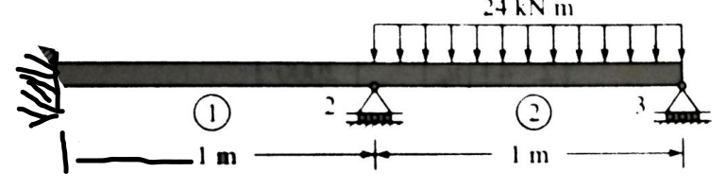  FIG – 1 | L5 | CO2 | [15M]
3. | a) | Write the strain displacement equation of axisymmetric problems using a cylindrical coordinate system. | L5 | CO3 | [8M]
 | b) | Derive the element stiffness matrix for the following figure 2 axisymmetric annular ring element.  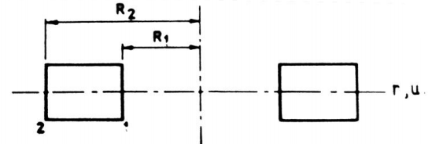  FIG-2 | L6 | CO3 | [7M]
4. |  | A cube of 50 mm side is modeled as a single hexahedral element. Derive the Jacobian matrix at the body centre of this hexahedral element. | L5 | CO4 | [15M]
5. |  | A composite slab consists of 3 materials of different conductivities i.e. 22 W/m K, 32 W/m K, 52 W/m K of thickness 0.31 m, 0.14 m and 0.14 m, respectively. The outer surface is 22º C and the inner surface is exposed to the convective heat transfer coefficient of 28 W/m² K, 800º C. Determine the temperature distribution within the wall. | L6 | CO5 | [15M]
6. | a) | Explain the properties of Eigen Values. | L3 | CO6 | [8M]
 | b) | Enumerate the various factors in the selection of proper element type in Finite Element Software. | L5 | CO6 | [7M]
7. |  | A two step bar subjected to loading conditions is shown in figure 3. The areas of the cross section of the two members are 200 mm² and 400 mm² . Determine the displacements at nodal points, the stresses in elements and the reactions at the supports.  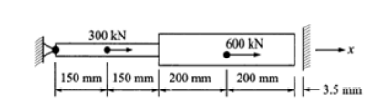  FIG-3 | L6 | CO1 | [15M]
8. |  | Write short notes on:  i) Triangular plate bending elements.  ii) Conforming and non-conforming plate bending elements.  iii) Mindlins C0 –continuity element. | L1 | CO4 | [15M]

-- 00 -- 00 –

